Deployment & Conclusion

Deployment
The completed Auto Ticket Classification solution is deployed in the ServiceNow environment after successful testing and validation. The configured ticket form, Flow Designer automation, classification rules, and access controls are made available to the intended users.
After deployment, students can create IT support tickets by entering their Caller Name and Short Description. The Flow Designer automatically processes the submitted description, identifies the predefined keywords, and assigns the appropriate Category and Subcategory. IT support staff can then access the classified tickets and proceed with the required support activities.
The deployment process also includes verifying that the flow is active, the classification rules are functioning correctly, and the appropriate users have the required access permissions. The system can be monitored after deployment to identify any classification issues or new types of IT requests that may require additional rules.

Conclusion
The Auto Ticket Classification system successfully automates the classification of IT support tickets using ServiceNow Flow Designer. By analyzing keywords in the Short Description, the system automatically assigns the appropriate Category and Subcategory without requiring manual classification.
The solution reduces the workload of IT support staff, minimizes classification errors, improves consistency, and speeds up the ticket-handling process. The use of Flow Designer also makes the solution easy to maintain and extend by allowing additional classification rules to be configured as new IT issues arise.
Overall, the developed solution provides a simple, efficient, and scalable approach to automating the initial classification of IT support requests while maintaining appropriate data access and security controls.
ACTIVITY:1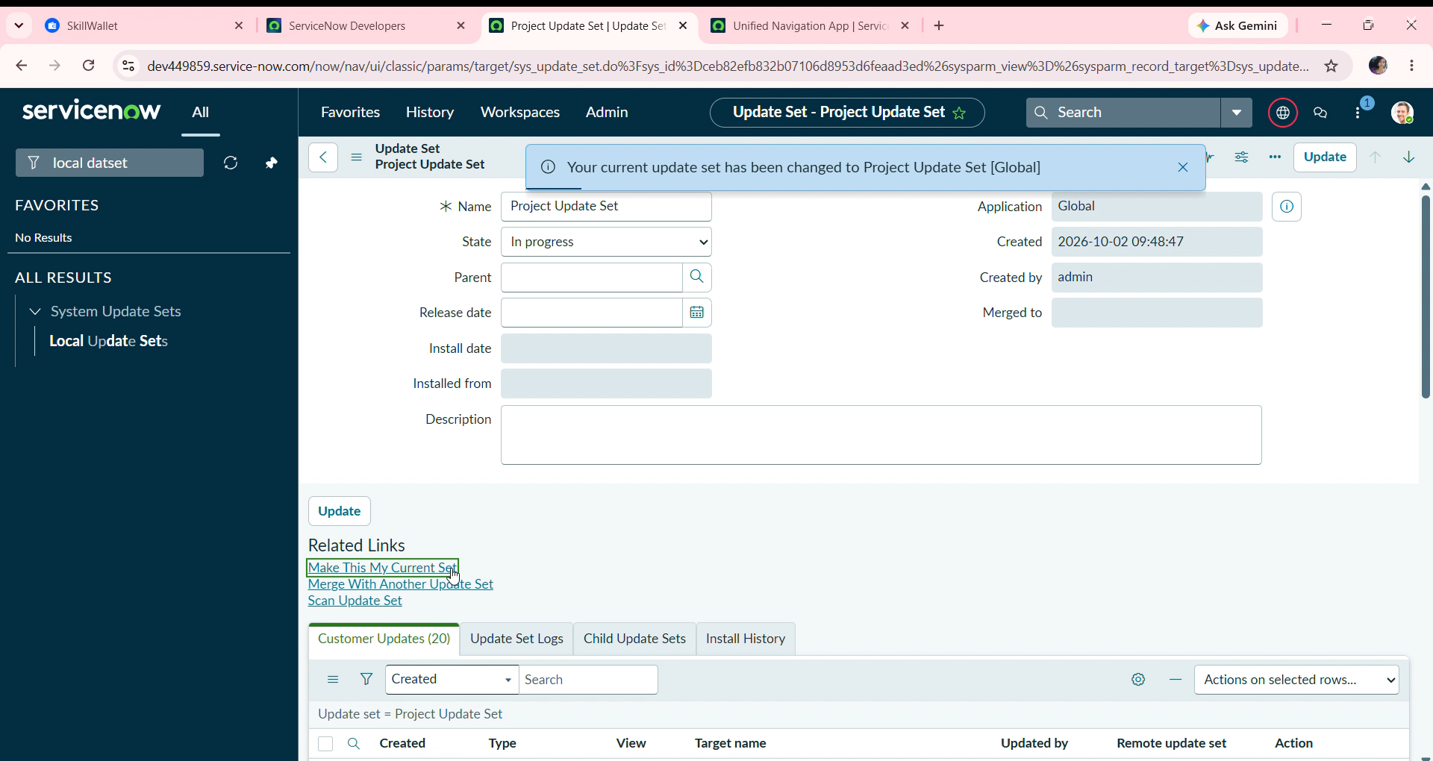
Go to All menus → Search For Local Update Sets.
Under System Update sets Select → Local Update sets.
Open the Project Update set.
Make the State From In progress to Complete.
Then Save the Form.
Under Related links Click Export to XML Option.
Then the Xml Format the Update set data will be downloaded to your system.
We can share through WhatsApp or Mail that downloaded file.
Then the Created Update set will transform to others in this way.

